Automation & AI Agent Services (n8n Workflows)
Enhance your business operations with custom-built automation workflows and intelligent AI agents designed using n8n, API integrations, and advanced AI prompting. These services streamline outreach, boost efficiency, and eliminate repetitive manual work.

🔹 1. AI-Powered Email Extraction & Lead Enrichment Pipeline
A fully automated workflow that collects emails from websites or directories and enriches every contact with:
- Name
- Company
- Industry
- Social links
- Domain insights
- Verification status
Result: Clean, verified, enriched leads delivered to your CRM or spreadsheet — automatically.
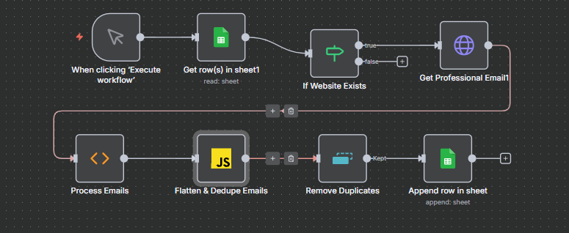

🔹 2. Automated AI Voice Assistant System
End-to-end AI voice agents integrated with n8n to handle:
- Lead qualification
- Appointment booking
- Customer support
- Follow-up calls
- Automated voice replies
Ideal for businesses needing seamless communication without hiring additional staff.

🔹 3. Geo-Search Automation & Business Locator AI
This workflow automatically:
- Searches businesses using Google Maps
- Extracts location, ratings, website, and contact info
- Sends leads directly into your sheets or CRM
- Helps build targeted outreach lists geographically
Perfect for agencies, marketing teams, and local service providers.
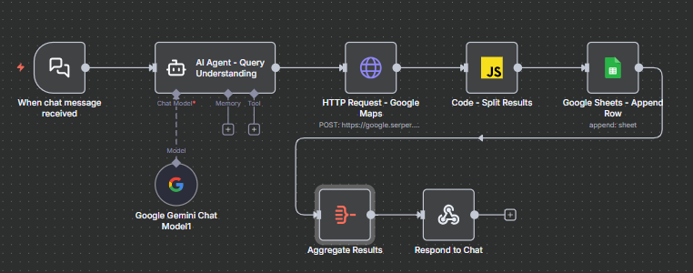

🔹 4. AI-Driven Personalized Outreach Workflow
A hyper-personalized cold email engine that analyzes:
- Lead details
- Website content
- Social profiles
- Pain points
- Industry trends
Then generates tailored cold emails and sends them automatically with tracking.
Delivers higher open rates, replies, and conversions.
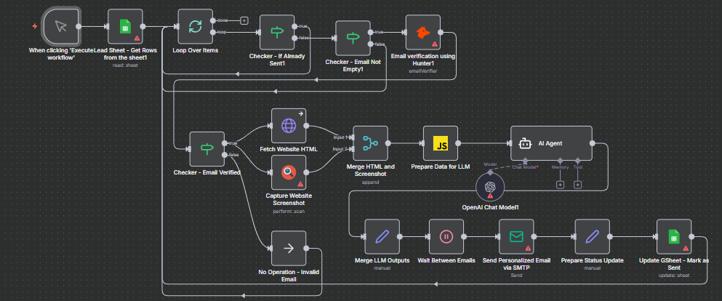

🔹 5. Social Media Scheduling & Daily Posting Automation
Polished Name: AI-Powered Social Posting & Scheduling System
Automates content publishing on:
- Twitter (X)
- LinkedIn
- Instagram
Features include:
- Auto-posting daily content
- Scheduled posts for weeks/months
- Pulling content from Sheets/Notion
- AI-generated captions & hashtags
- Consistent presence without manual posting
Perfect for agencies, founders, and brands who want consistent visibility.
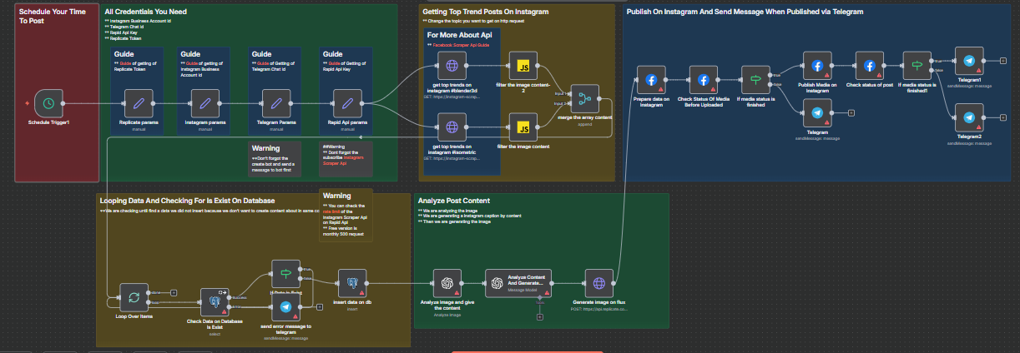
Hv Zoom-in Snapshots:
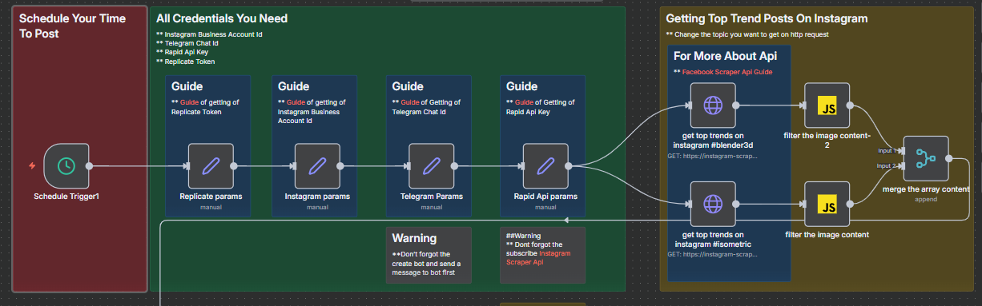
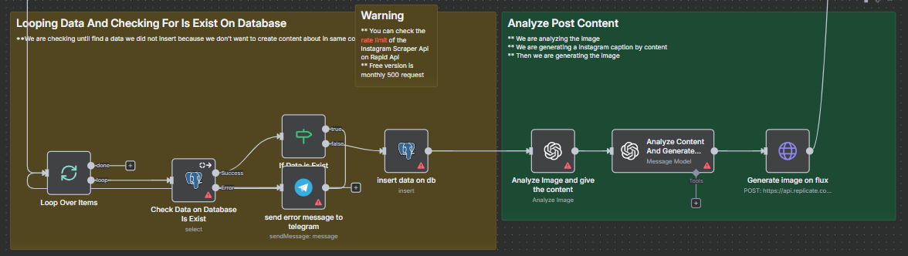
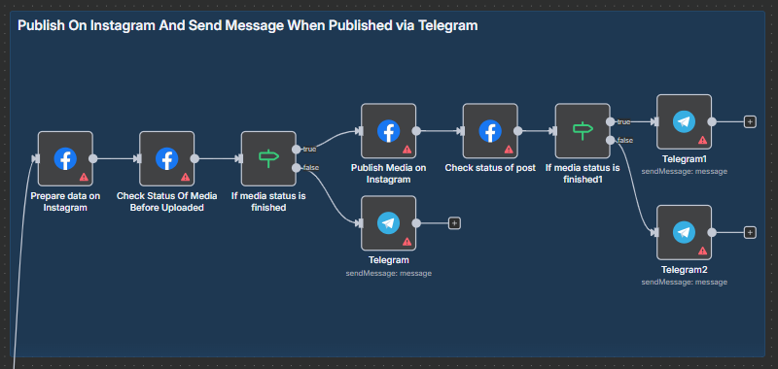

🔹 6. Instagram DM Automation (AI Messaging Agent)
Polished Name: AI Agent for Instagram DM Automation
A fully automated, AI-powered Instagram DM workflow designed to manage and scale your Instagram communication:

Instagram DM AI Agent Features:
- Automatically replies to incoming DMs
- Generates personalized responses based on user questions
- Qualifies leads through real-time conversational AI
- Sends product links, pricing, offers, or FAQs
- Routes hot leads to Google Sheets, CRM, or email
- Handles follow-ups and drip-style messages
- Works 24/7 without needing manual monitoring
Perfect for businesses, creators, e-commerce brands, agencies, and service providers looking to automate Instagram outreach and customer engagement.
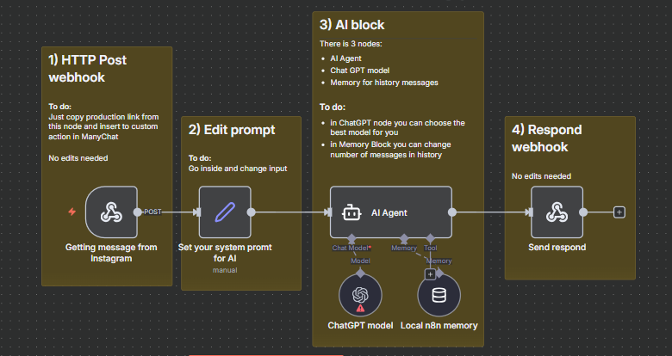

Why These Workflows Stand Out

✔ Fully automated from start to end

✔ Built using n8n (open-source, scalable, cost-efficient)

✔ Integrates with your existing tools (Sheets, CRMs, email, APIs)

✔ AI-enhanced for smarter decisions and personalized outputs

✔ Zero coding required on your end — everything is delivered ready-to-use

Business Offer
Businesses looking for automated, AI-powered workflows like these can easily purchase them at affordable prices.
Each workflow package comes with:

✔ 100+ authenticated & high-potential leads

✔ Full setup and customization

✔ Integration with your existing systems

✔ Ongoing support if needed

Whether you're a startup, agency, SaaS company, or service-based business, all workflows can be tailored specifically to your goals, platforms, audience, and operational requirements.

